**Office 365 Secure Email Information**

**Office 365 Message Secure Email Encryption:**

1. A secure email message that is encrypted by Office 365 Message Encryption is delivered to a recipient’s inbox just like any other email message, but it contains an HTML file attachment. After opening the attachment, the recipient can sign in or use a one-time passcode to view the message on the Office 365 Message Encryption portal. To send a secure email users send email with [Secure Email] in the subject line, including the square brackets.
2. The following diagram summarizes the passage of an email message through the encryption and decryption process: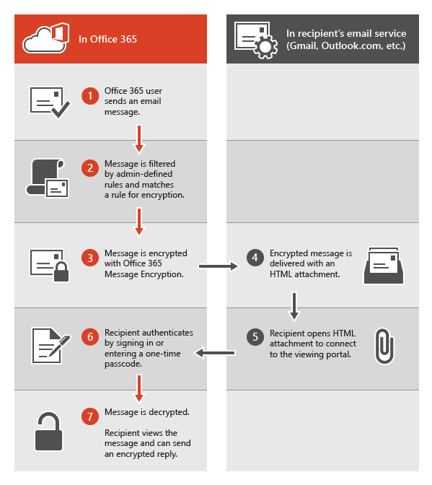
3. **Office 365 Message Encryption,** email messages are encrypted automatically when users include the words**, [Secure Email]** including the square brackets, in the subject line of the email. The recipients will follow instructions in the message to open the attachment and authenticate by using a Microsoft account or a work account associated with Office 365
4. **Gateway-to-Gateway encryption:** 
   * + **New actions on forced TLS**: Email delivery actions have changed when forced TLS delivery is set for a domain outside the State of TN. The receiving server is checked for having a valid TLS certificate before sending, if the receiving server does not have a valid TLS certificate the email is held in the outbound queue for up to two days. If at any time a valid certificate is detected on the receiving server the email will be delivered, however after 2 days of attempting delivery the queued email will be dropped and a notification email sent to the sender indicating delivery failure.
5. **Receiving and responding to encrypted messages**

When an external recipient receives an encrypted message from the State of TN, they see an encrypted attachment and an instruction to view the encrypted message.

If recipients don’t have either account, they’re directed to create a Microsoft account that will let them sign in to view the encrypted message. Alternatively, recipients can choose to get a one-time passcode to view the message. After signing in or using a one-time passcode, recipients can view the decrypted message and send an encrypted reply. Recipients accessing secure email from a mobile device will have to use the “Use a one-time passcode” option

.

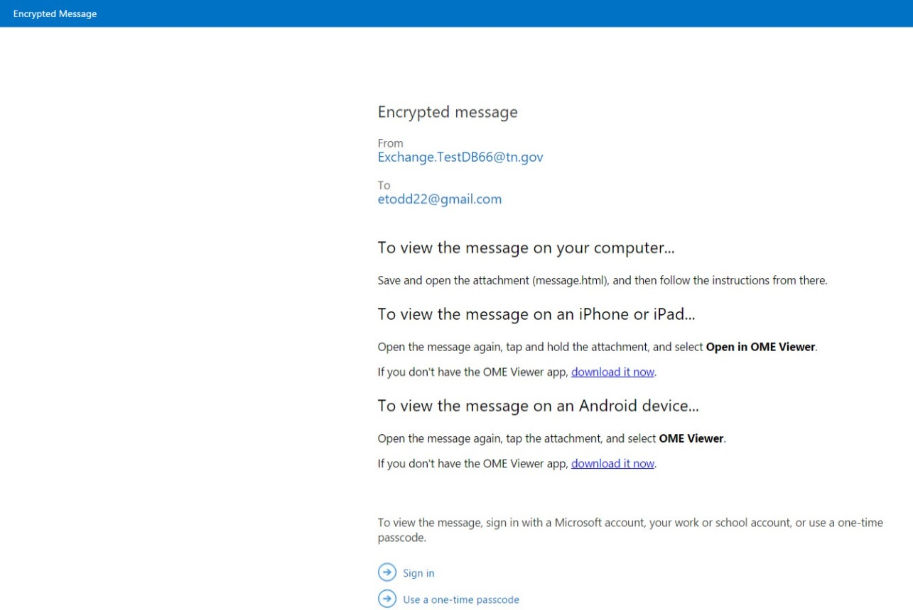

Example: of login to Microsoft Office account:

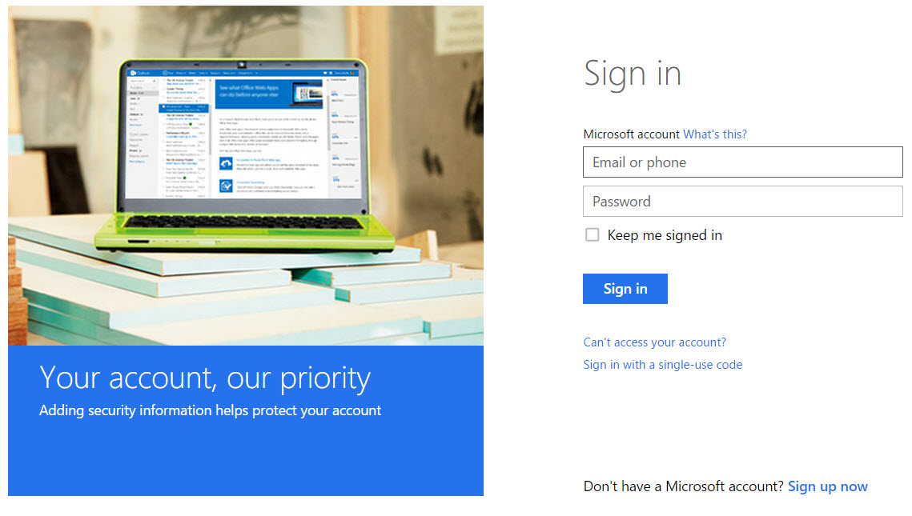

Example of email notification to get a one-time passcode:

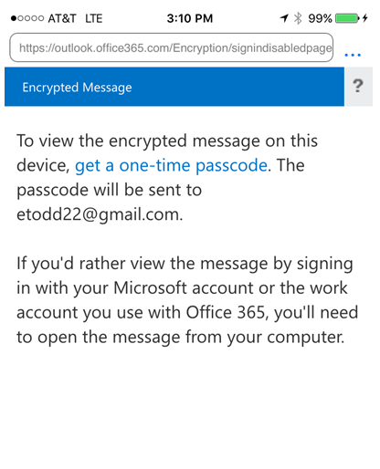

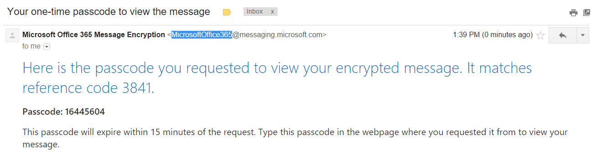

Sign in to the encryption portal with a Microsoft account, as instructed in the message. If you don’t have a Microsoft account, you can choose the option to create one associated with your email address. In order to view the encrypted message, the email address for the Microsoft account must match the address to which the encrypted message was sent. If you’re already signed in, you won’t have to sign in again. After signing in, you can view the contents of the encrypted message.

The passcode is sent to you in an email message. Get the passcode, enter it, and then click continue.

**Accessing secure email from a mobile device**

|  |  |
| --- | --- |
| You get a secure email from Office 365 | It tells you to open the email on a mobile device you have to have OME Viewer installed. So you have to install it |
| C:\Users\ag03205\Desktop\New folder\IMG_0706.PNG | C:\Users\ag03205\Desktop\New folder\IMG_0716.PNG |
| Then to open the secure email you tap and hold the attachment and then choose Copy to OME Viewer | Then it will ask you to Sign in or Use a one-time passcode |
| C:\Users\ag03205\Desktop\New folder\IMG_0708.PNG | C:\Users\ag03205\Desktop\New folder\IMG_0709.PNG |
| To view a secure email on a mobile device you have to choose the get a one-time passcode I tried Sign in | So you click the get a one-time passcode and it will send the passcode to the email address that the secure email was sent to |
| C:\Users\ag03205\Desktop\New folder\IMG_0710.PNG | C:\Users\ag03205\Desktop\New folder\IMG_0711.PNG |
| You get the passcode and enter it into the Passcode area. Then tap on Continue | Then you can look at your secure email and reply, reply to all, or forward the secure email |
| C:\Users\ag03205\Desktop\New folder\IMG_0712.PNG | C:\Users\ag03205\Desktop\New folder\IMG_0715.PNG |